①

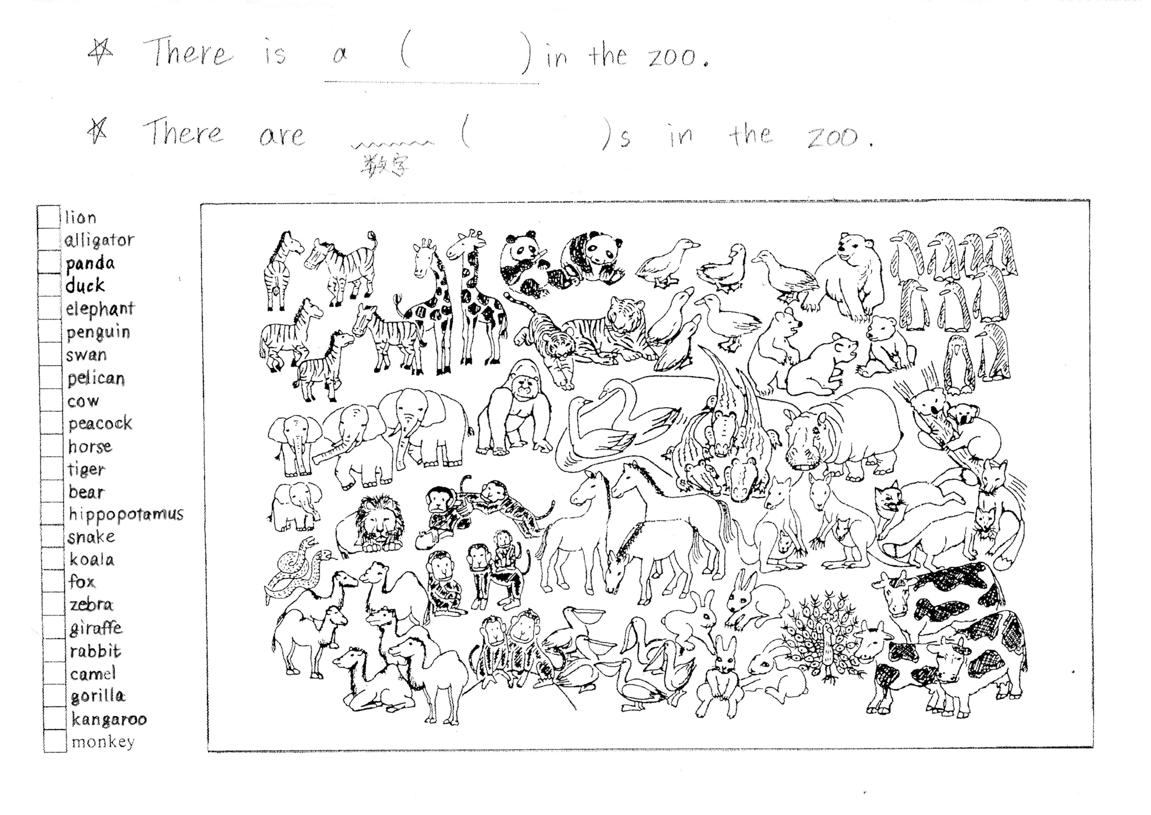

☆　There is a ( ) in the zoo.

☆ There are 数　字 ( ) s in the zoo.

* lion
* alligator
* panda
* duck
* elephant
* penguin
* swan
* pelican
* cow
* tiger
* bear
* hippopotamus
* koala
* fox
* zebra
* giraffe
* rabbit
* camel
* gorilla
* kangaroo
* monkey
* peacock
* horse
* snake

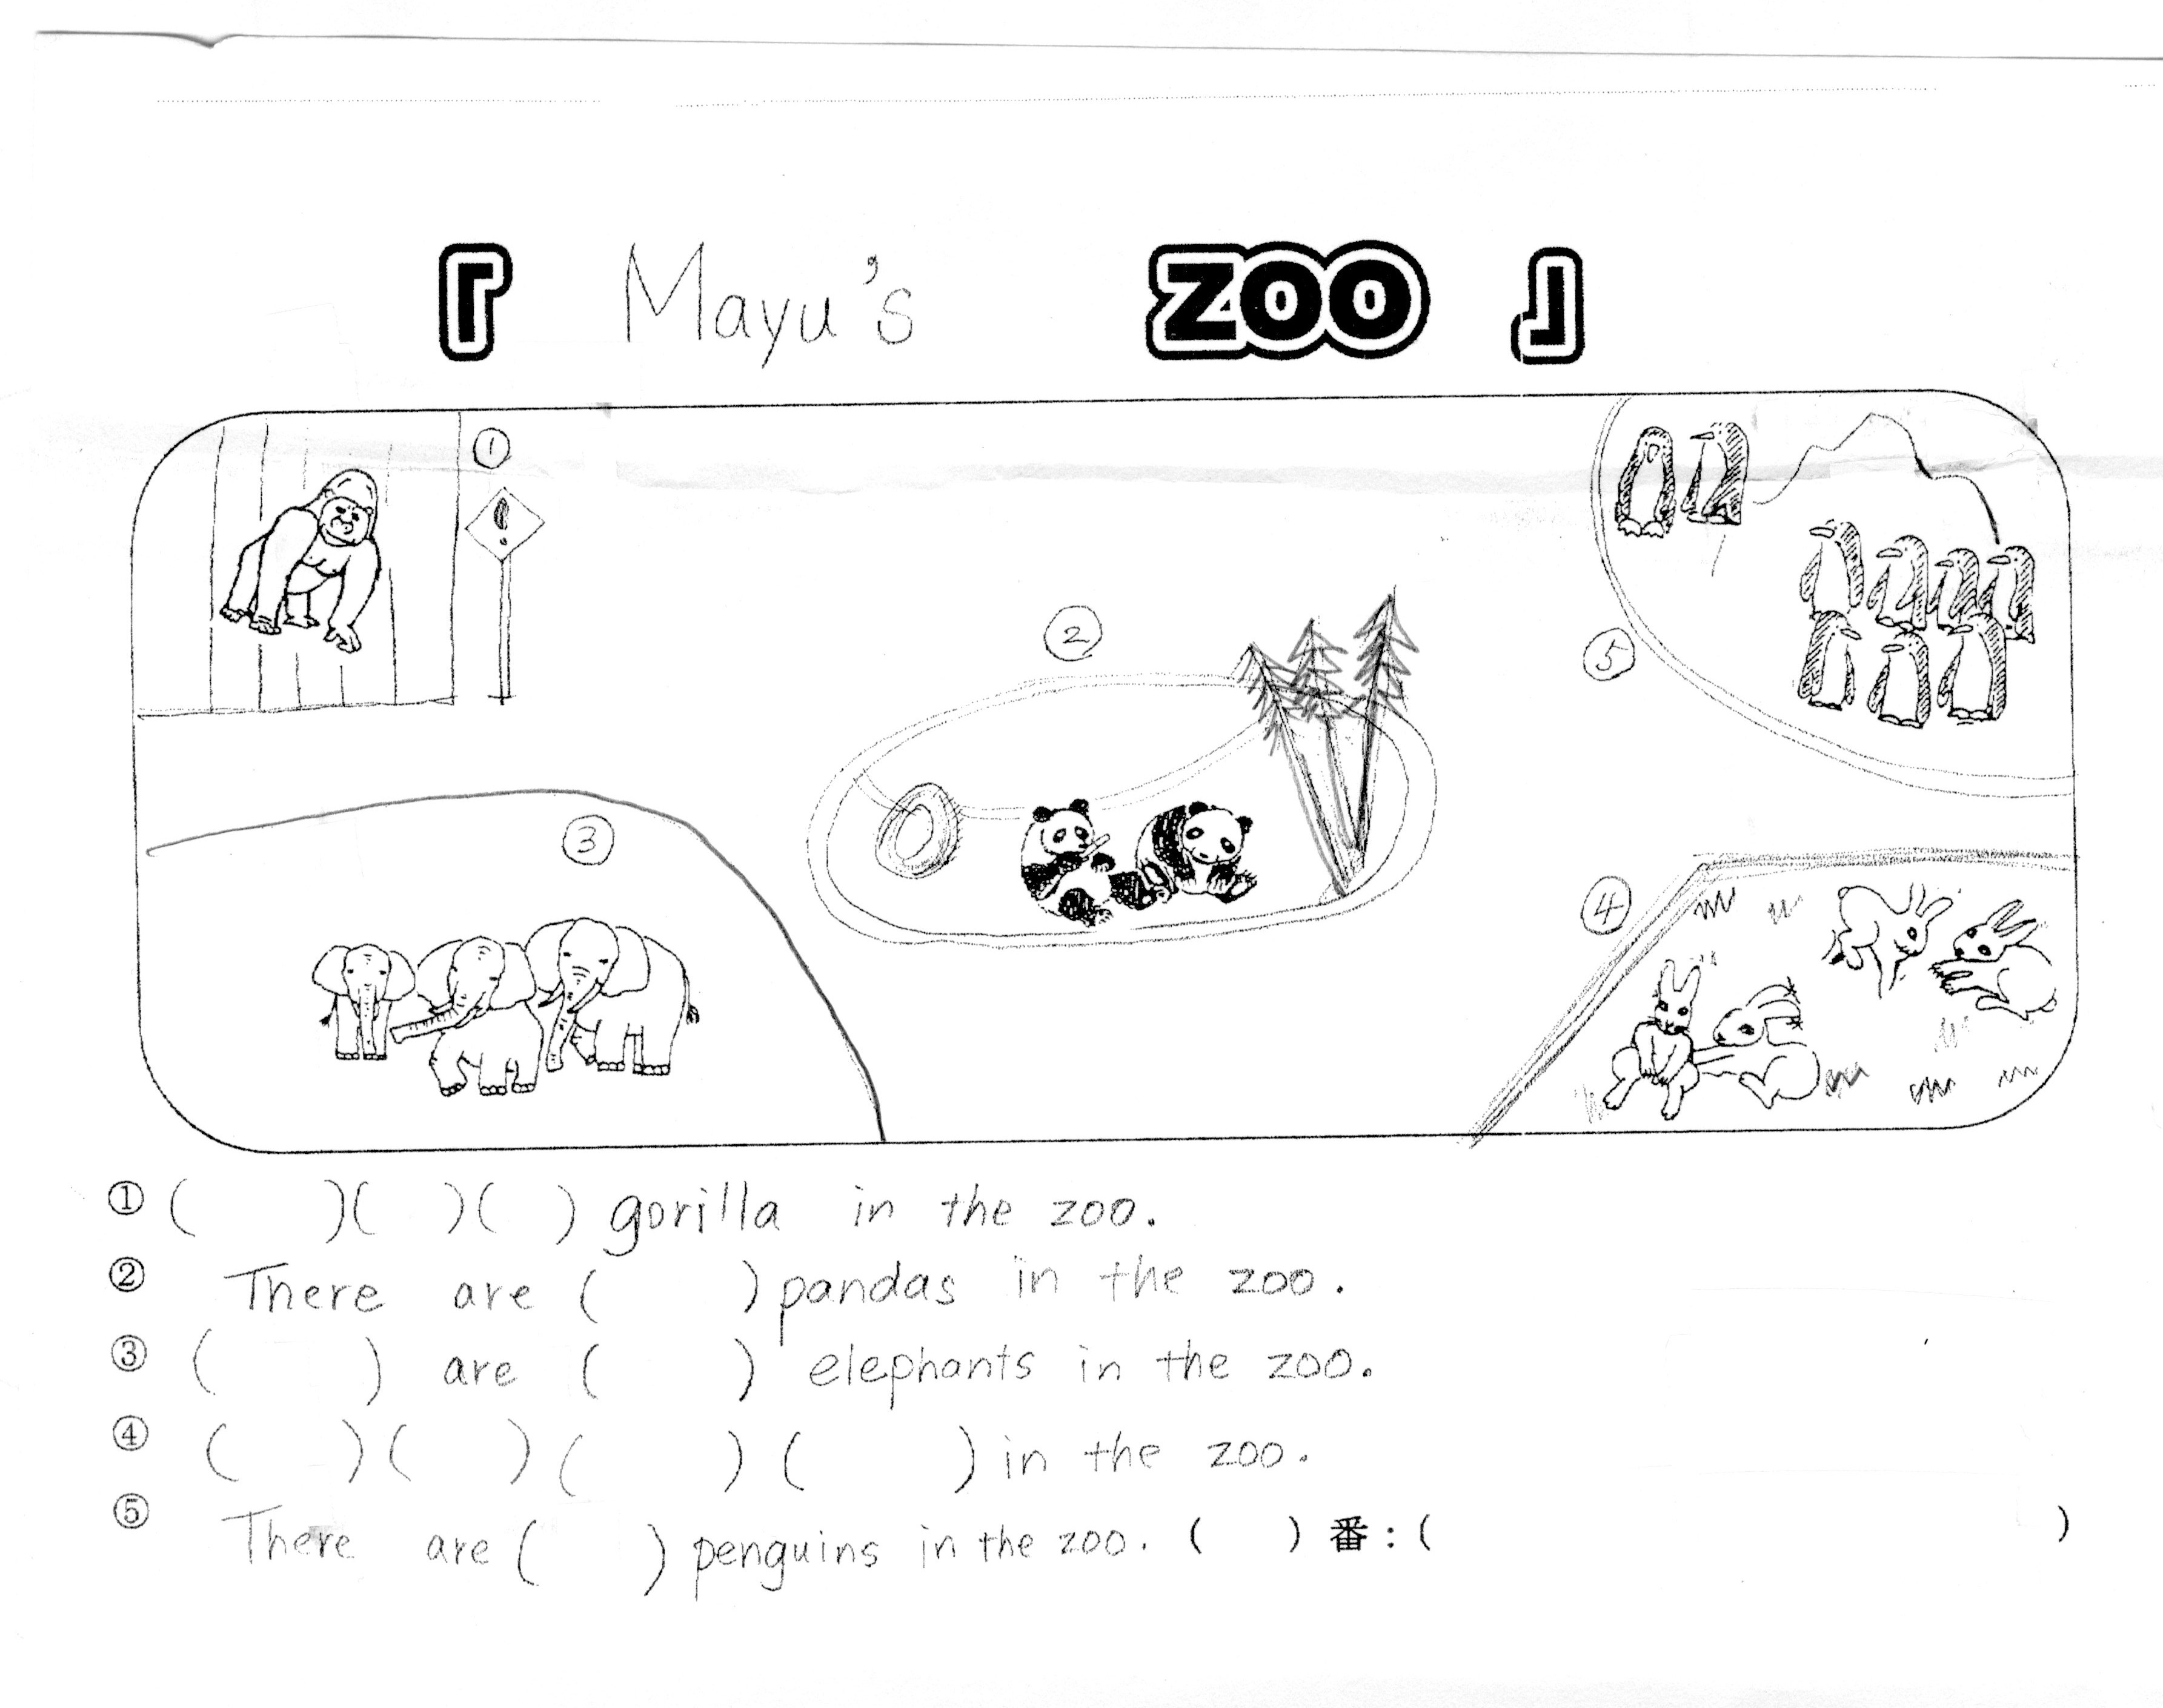②

1. 