Pollyanna
My Pollyanna Tree

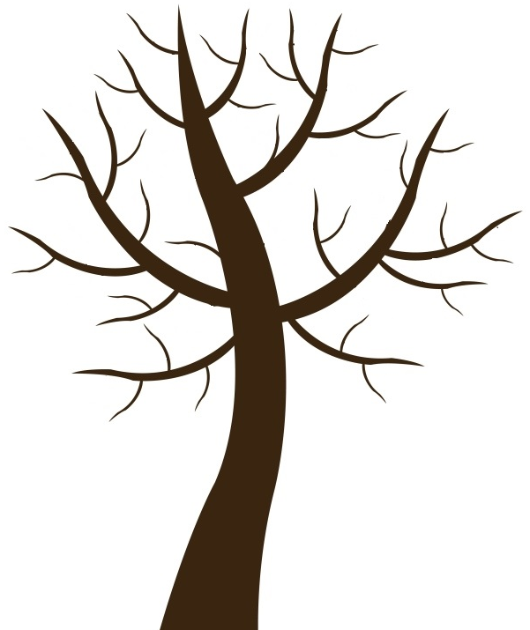
No. ( ) Name ( )

